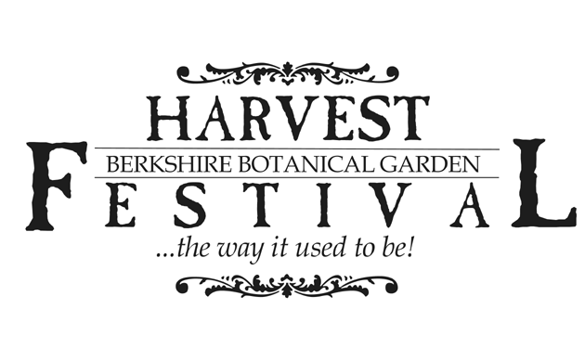



BUSINESS NAME:

CONTACT PERSON:

ADDRESS:

CITY: STATE: ZIP:

EMAIL (PRINT NEATLY PLEASE):

PHONE: CELL:

WEBSITE:

**BOOTH FEES**

|  |  |  |  |  |
| --- | --- | --- | --- | --- |
| **Check** | **Vendor Classification** | **Before** | **Before** | **After** |
| **one** | *See definitions on reverse* | **6/1/22** | **9/1/22** | **9/1/22** |
|  | Artists/Crafters/Growers | $200 | $250 | $350 |
|  | Retail & Wholesale | $290 | $340 | $450 |
|  | Snacks | $275 | $330 | $400 |
|  | Food & Alcohol | $425 | $500 | $575 |
|  | Not for Profit | $100 | $125 | $150 |
|  | Not for Profit Serving Food | $190 | $220 | $250 |

**BOOTH INFORMATION**

|  |  |  |  |
| --- | --- | --- | --- |
| **Item** | **How Many?** | **Price** | **Total** |
| 10’ x 10’ booth space  *You provide the tent* |  | @ $  *from table above* |  |
| Corner booth guarantee  *Limited availability* |  | @ $50 |  |
| 8’ x 30” table |  | @ $25 |  |
| Folding chair |  | @ $5 |  |
|  |  | **TOTAL** | $ |

**2022 Harvest Festival Application continued…**

**PAYMENT INFORMATION**

*Please make check payable to Berkshire Botanical Garden*

1-I am paying with the enclosed check ☐

2-I am paying with a credit card: Mastercard ☐ Visa ☐ American Express ☐ Discover ☐

Credit card #: Exp. #: / CV:

Signature: Date:

**NEW VENDOR INFORMATION**  
If you have not been a vendor at the Harvest Festival at the Berkshire Botanical Garden before or it has been more than two years since you have participated, please provide the following information.

Description of your work or product:

Price range of your work or product:

Provide visual of your work or product (use one of these methods to familiarize me with your work:

Online site to view ☐  
Photographs will be emailed to daudia@berkshirebotanical.org

Photographs or prints of photographs are enclosed ☐

**VENDOR CLASSIFICATION**

**Artists/Crafters/Growers** – Homemade or homegrown by you, sold exclusively from homes, craft shows, or galleries

**Retail & Wholesale** – All imports and any merchandise sold from storefront, trade show, catalog, or bought (rather than made by you)

**Snacks** – Food that is not prepared onsite (bottled drinks, ice cream, fruit, cookies, candies)

**Food & Alcohol** – Food that is prepared onsite (cooked or heated) and alcoholic beverages. Note: electricity is very limited and only available certain areas.

**Not for Profit** – Please include 501c3 or other documentation

By signing below, I am stating that I have read and agree to comply with the Berkshire Botanical Garden Harvest Festival guidelines.

Signature: Date:

**Submit application and payment to:** **Dana Audia**

**Berkshire Botanical Garden**

**Box 826**

**Stockbridge, MA 01262**